Children's Product Certificate
This assessment of certification verifies the item listed below conforms to, at a minimum, the regulations, rules and/or standards as they pertain to said listed item and is affirmed by the below parties.
Importer: Hayes Specialties Corporation
Address : 1761 East Genesee Avenue
Saginaw, MI 48601
(989)755-6541

Product Number: 16929
Description: SPLAT EMOJI BALL - YELLOW
HSC Purchase Order Number: N/A
Date of Manufacture: July-16
Place of Manufacture: China

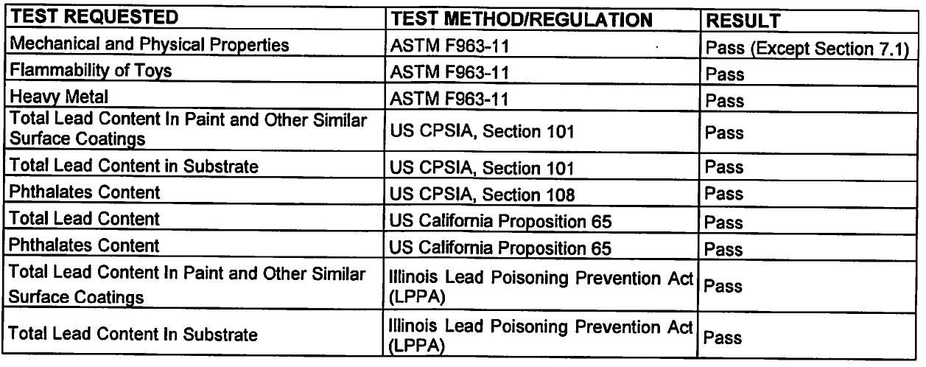

Testing Agency: Eurofins Product Testing Service
(Shanghai) Co., LTD
Address: No. 395 West Jiangchang Road
Zhabei District
Shanghai, China
Date of Testing: 07/20/2016-07/28/2016

Record Keeper: Dennis Schluckbier
Hayes Specialties Corporation (989)755-6541 x208 das@ehayes.com
1761 East Genesee Avenue
Saginaw, MI 48601

