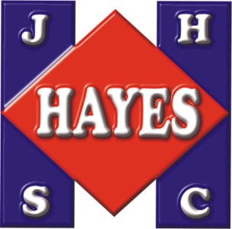

### **Hayes Specialties Corporation**

**www.eHayes.com**

**1761 East Genesee Ave, Saginaw, MI 48601 USA**

**Local/Intl (989) 755-6541 Fax (989) 755-2341**

**Toll Free (800) 521-5219 e-mail: Info@eHayes.com**

**Additional Sales Offices: Mid-Atlantic Mart, Philadelphia and Regent Building, Chicago**

Jan 2, 2024

Regarding items:

18377 Mini Sticky Dinosaur Set

18378 Mini Sticky Astronaut Set

18379 Mini Sticky Unicorn Set

Hayes Specialties attests that the above three items fall under the “extent practicable” exemption from labeling directly onto the product for the following reasons:

Given the surface area of each item, the inconsistent shape of each, and the soft plastic material used to produce this item, it is not possible for a permanent print to remain with this item. Therefore, these items do not have individual tracking printed directly on each piece/set. The full tracking info is displayed on each package.

Submitted By:

Jim Hayes Jr.

President